**Automation Technical Test**

**Purpose**

As part of our hiring process for technical roles, we require all candidates to complete a small technical exercise. This is an integral part of our process to assess an individual’s technical ability when completing an activity in their own time.

Given the importance of this exercise to our hiring process, we highly recommend you give this adequate consideration and address this task as you would do any other professional assignment in your current/previous workplace.

**Instructions**

* There are two parts to this technical assessment
  + A written assessment of your ability to tackle a typical testing problem you might face as a Sr. test analyst/engineer

[DM] Special migration projects are very typical for QA ,because test data is same,technology and design archtiture different some times test data would not displayed in proper way.

* + A code-based assessment, testing your ability to automate a test scenario
* Written answers for part 1 should be submitted in a suitable format - e.g. a word document
* Please work on a GitHub, create the New branch within this repository and when you are happy to submit, create a pull request back into the main branch
* Please use the pull request to comment on any aspects of your solution that you didn’t have time to complete, are not complete to your satisfaction or are not working
* Would you please add a markdown file with instructions on how to set up and run your solution to question 2

**Question 1**

**Introduction**

The following is the main form of an application that converts values from one currency to another. The application has the following characteristics:

* The collection of currencies, exchange rates, and rules for applying commission are held in a shared database, accessed by multiple users of this application on a network.

[DM] :- Scenario for facthing data from database

* 1. Check user is able to access more than one access
  2. Check user is abale to fatch the currencies, exchange rates and one table and commission other table to access more than one user access
* The user of this form selects a base currency, a target currency, specifies an amount (expressed in the base currency), can choose to include or exclude commission, and then hits the Convert button to generate the equivalent value in the target currency. The screenshot below shows that value where “N/A” is displayed.

[DM] : Scenario’s

* 1. Check user is able to select base currentcy (GBP) and target currency(USD) and click on select the check box “include or exclude commission” and click on convert button Check if the equivalent value in the target currency then amount in target currency field should be displayed as N/A.
  2. Check user is able to select base currentcy (GBP) and target currency(USD) and uncheck box “include or exclude commission” and click on convert button Check if the equivalent value in the target currency then amount in target currency field should be displayed as N/A.
  3. Check user is able to select base currentcy (GBP) and target currency(USD) and click on select the check box “include or exclude commission” and click on convert button Check if not equivalent value in the target currency then amount in target currency field should not be displayed as N/A.
  4. Check user is able to select base currentcy (GBP) and target currency(USD) and uncheck box “include or exclude commission” and click on convert button Check if the equivalent value in the target currency then amount in target currency field should not be displayed as N/A.
* The separate “Maintain currencies” form (not shown) provides operations for adding, deleting and editing currencies.

[DM] Scenario : **Pre-request** : user is having an entitled to access add, update and delete to currencies related database.

* 1. Check user is able to add single currency currencies form Maintain currencies form
  2. Check user is bale to add multiple currencies currencies form Maintain currencies form
  3. Check user is able to edit single currency or multiple currencies currencies form Maintain currencies form
  4. Check user is able to delet single currency or multiple currencies form Maintain currencies form
* A separate process constantly updates the database with exchange rates for any recognised currencies (you do not need to worry about how this works, but you do have control over stopping and starting it).

[DM] Scenario : Pre-requiest : user is having entitlement to give access control

* 1. Check user is able to access exchange rate page.
  2. Check user is able to stop the access control for exchange rate page
  3. Check user is able to access and modify exchange rate page based on access control.
* The separate “Maintain commission rates” form (not shown) provides operations for specifying a minimum commission value and a collection of commission rates for different ranges of values. The minimum commission value and ranges are defined in Sterling. For example, for “amount to convert” values in the range of 0.01 to 100.00 pounds Sterling, the commission rate is 5%. An example minimum commission value is £10.

[DM] Scneario : pre request All assumation value.

* 1. Check user is able to convert minimum commission value and ranges 0.01 to 100.00 GBP the commission rate is 5%.
  2. Check user is able to convert minimum commission value more than 100.01 to 200.00 GBP then commission value is 10

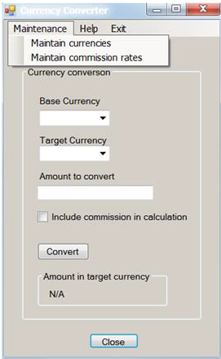

Given the information provided, please answer the following questions:

1. Using the database and the GUI, how would you test the functionality of this form?

[DM] : Scenario’s : pre-request for user is having access control data base and GUI

* 1. Check user is able to add/modify/delete currencies from GUI and same verified in database
  2. Check user is able to convert currencies from GUI and same verified in database
  3. Check user is able to view commission after convert currencies from GUI and same verified in database

1. What tests would you perform to test the operations supported by the “Maintain currencies” form?

[DM]: Scenario:

* 1. Check user is able to add/modify/delete operation from “Maintain currencies” form.

1. What tests would you perform to test the operations supported by the “Maintain commission rates” form?

[DM] Scenario:

* 1. Check user is able to perform the currencies conversion and verify commission rate 5% from range 0.01 to 100.00
  2. Check user is able to perform the currencies conversion and verify commission rate 10 from range 100.01 to 200.00

1. What tests would you perform on the form above to test accessibility?

[DM] Scenario : Verify User entitlement

* 1. Check user is able to access control for both form
  2. Check user is able to add/modify/delete from one form
  3. Check user is able to covert currencies and calculate commion rate.

1. If you were automating the testing of this form for regression test purposes, what would you hope the developer had done to make the automation easier?

[DM] : Check the Priority scenarios are working as expected make sure and cross check it and anychage request make this area then should not impact it.

1. If this application were used internationally, what further tests would you perform?

[DM] Scenario’s

* 1. check the entitlement for countrywise
  2. Check the multiple currencies convert from different country conversion/add/edit/delete and commission rate
  3. Check the laguage Test

1. The screenshot of the form above shows immediately apparent user interface issues (you may have mentioned some of these in previous answers)?

[DM] Scenatio’s

* 1. If scenario are not working as expected then raise issues/defect/bug for particular test.
  2. If all passed then this question would not arised.

**Notes**

* In answering the questions, identifying tests is sufficient
* [DM] : Identified test is not sufficient for exect test cases and meet expected results
* Details of test data and expected results are not required where they can be inferred
* [DM] : Details of test data and expected results are required to meet requirements.
* Aim for an answer no longer than 1200 words for this entire section
* [DM] : if all requirement and priorites are meet within less than its expected.

**Question 2**

**Introduction**

For this question, you can use any C#/JavaScript framework of your choice. We want you to automate the scenarios below using the Chrome browser.

**Test Scenario**

1. Open the following URL: <https://www.moneycorp.com/en-gb/> and verify
2. Change the language and region from the top right corner to USA (English) and verify See example snippet.

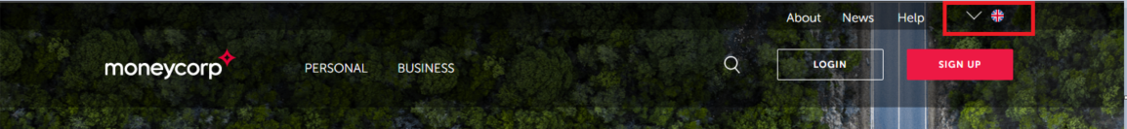

1. Click Find out more for “Foreign exchange solutions” Validate if you have arrived on the page
2. Search for the word “international payments” using the search box
3. Validate if you have arrived on the result page
4. Validate that each article in the list displays a link that starts with <https://www.moneycorp.com/en-us/>

**Question 3**

**Introduction**

The following is a simple API that suggests tasks based on parameters passed in, <https://www.boredapi.com/>

Generate three activities for two people that have a type social and assert that the results are appropriate.

Please write tests using the C# framework.

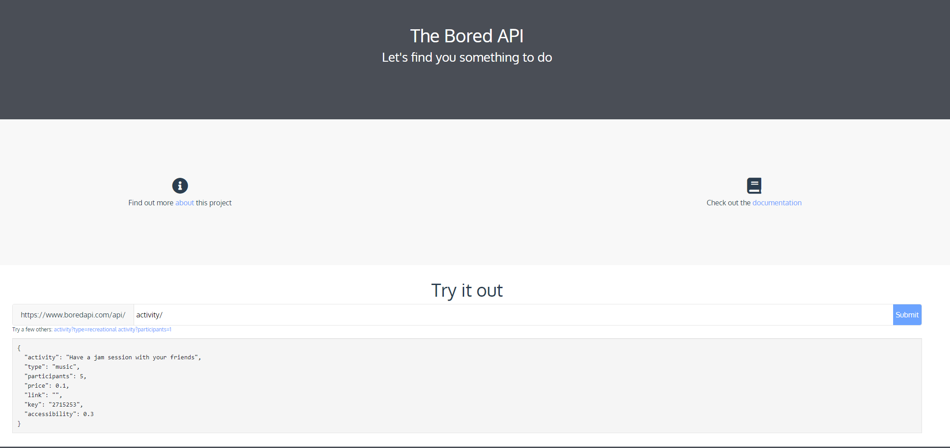

**Evaluation**

Evaluation will be done on the following criteria:

* Clean and tidiness of the solution

[DM] : An important task that can help us maintain a clean and organized workspace and improve efficiency, and prevent any potential issues.

* Design and architecture

[DM] Proper work flow of Application/Testing framwork is important, so that its easy to use and maintain it

* Readability

[DM] suppose to use coding standard and naming convension,easy impelement and its easy to understand the code

* Maintainability
* [DM] if following the standard coding and structured like POM model its easy maintainable.
* Stability of the tests

[DM] Keep on check product and maintain stable

* Clarity of setup and execution documentation

[DM] Maintain proper documentation step by step followed and its easy to understand unknow member.

Please provide instructions for setting up an environment from scratch and how to run the tests.